shopping-bag.png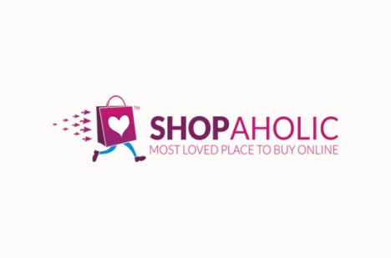

Search

women

living

kids

Men

Top offers

**Shop by Category**

View more

**Affordables**

discount

View more

**Top brands on offer**

**Quick links social media links customer policies contact us**

Navigation bar includes :

* Logo
* Links
  + - * + Men : will direct you to all the category, offer etc. On men’s stuff.
        + Women : will direct you to all the category, offer etc. On women’s stuff.
        + Kids : will direct you to all the category, offer etc. On kids’s stuff.
        + Living : will direct you to all the category, offer etc. On decorative ,essentials stuff.
* Search box : here you can search product,brand

 : it is account icon lead you to login/register page

shopping-bag.png : it is wishlist icon

:it is a cart icon

Top offers section : this section will contain imagemap which will direct to to the top deals on different categories....

Top brand on offer : this section will consists brand with offers and discount going on them...on click which will leads you to all the products with there discounted price of specific brand.

Affordable : this is specially for shopaholic’s those who don’t want to invest much but wants to got with trend going on...

Shop by category : if one hs already decided what he or she wana buy ( Indian wear , jeans dresses etc).... can select product type..and add product in cart they like...



H&M

bb

FOOTER SAME AS HOME PAGE

Rs.609 ~~1200~~ (50%)

Product name

DISCOUNT

PRICE RANGE

COLOURS

BRAND

CATEGORIES

NAVBAR SAME AS HOMEPAGE

**W**

more info >

* Get it by Sat, Aug 20
* Pay on delivery available
* Easy 30 days return & exchange available

More mehroon >

More kurta>

More kurta by W >

Similar products >

Reviews > RATINGS

4.1

69 Verified Buyers

5

38

4

15

3

7

2

5

1

4

WHAT CUSTOMERS SAID

Fit

As Expected (100%)

Length

As Expected (50%)

Transparency

Not Transparent (100%)

View Details

**PRODUCT DETAILS**

Colour: maroon

Geometric striped

Keyhole neck

Long, regular sleeves

**Size & Fit**

The model (height 5'8) is wearing a size S

Material & Care

Fabric Name : Flax, Fabric Composition : 88% Cotton 12 % Flax, Delicate Wash

Specifications

Sleeve Length

Long Sleeves See More

Pin code change

DILIVERY OPTIONS

WISHLIST 

ADD TO BAG 

**SIZE CHART >**

SIZES

**Inclusive of all taxes**

Rs. 1199 MRP Rs~~.1999~~ (40% OFF)

69 ratings

4.1

A line kurti with gotta work on neck beautiful mehroon colour.

MY WISHLIST 17 items

Rs.749 ~~Rs.1,499~~(50%OFF)

HRX Hritik Roshan liestyle...

ADD TO BAG

You saved additional Rs 100

1 coupon applied

**Edit**

**COUPONS**

CHANGES

House no. Xyz ,street A,...................

Deliver to : guneet , 201308



**Need help? Contact us**

**YOU may also** : :like

**PLACE ORDER**

**TOTAL AMOUNT Rs 1046**

Convience fee **know more** FREE ~~99~~

Coupon discount apply

Discount on MRP Rs 1252

Total MRP Rs 2298

PRICE DETAILS ( selected items)

Gift wrap and add message

At just Rs 25

ADD GIFT WRAP

**Buying for loved one?**

**GIFTING & PERSONALISATION**

ADD MORE FROM WISHLIST

Qty : 1

Size : L

Rs 599 ~~1499~~ (60% off)

**Delivery bu tomorrow**

HRX by Hritik Roshan lifestyle women black.

HRX by Hritik Roshan

COUPON DISCOUNT Rs 100

2/2 SELECTED REMOVE | move to WISHLIST

**View items out of stock !**

Yay! No convience fee on this order

Show more>

Dfd dafdf,sd, pg,rf fgklgd[hd[ll ccvbffffgrlgflg[vvvv

cc

**AVAILABLE offer**